Understanding Audience –

A Machine Learning Approach to Customer Segmentation

**Team Number:**

**Submitted To: SmartInternz Team**

**Batch: VIT – AP AI/ML Morning Batch**

**Year: 2023**

**DONE BY:**

**Vaishnavi T Sundari Dhulipala – 21BCE9174**

**Vintha Kuyili Ramyasri – 21BCE9204**

**Lakshmi Srujana Vankayala – 21BCE9181**

**Deepthimahanty Harshita – 21BCE9230**

 PHASE – III:

**Technology Stack (Architecture & Stack)**

|  |  |
| --- | --- |
| Date | 12 November 2023 |
| Team ID | Team-591849 |
| Project Name | Project – Understanding Audience |
| Maximum Marks | 4 Marks |

**Technical Architecture:**

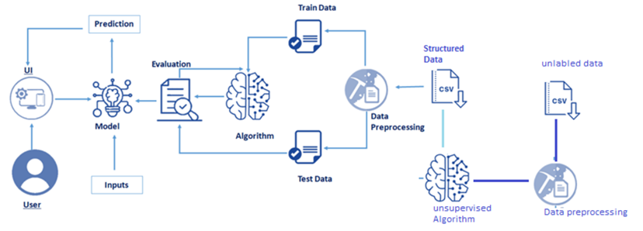

**Table-1 : Components & Technologies:**

|  |  |  |  |
| --- | --- | --- | --- |
| **S.No** | **Component** | **Description** | **Technology** |
| 1 | User Interface | How users interact with the application (Web UI, Mobile App, Chatbot, etc.) | HTML, CSS, JavaScript / React Js |
| 2 | Application Logic-1 | It serves as the primary logic layer responsible for processing and analysing user input, managing data, and facilitating communication between the user interface and backend functionalities. It plays a crucial role in handling core application processes, such as data preprocessing, feature scaling, and interfacing with the machine learning model for customer segmentation. | Python |
| 3 | Application Logic-2 | Integration of IBM Watson Speech to Text (STT) service. This component is responsible for converting speech input from users into text, enabling seamless interaction through spoken commands or queries. It enhances the user experience by providing a speech-to-text capability, which can be further processed by other components for analysis and decision-making. | IBM Watson Speech to Text (STT) service |
| 4 | Application Logic-3 | Integration of IBM Watson Assistant. This component focuses on handling conversational interactions with users, providing a chatbot-like experience. It interprets user queries, responds with relevant information, and assists in guiding users through the application's functionalities. IBM Watson Assistant enhances user engagement and streamlines the communication process. | IBM Watson Assistant |
| 5 | Database | Data Type, Configurations, etc. | MySQL |
| 6 | Cloud Database | Database Service on Cloud | IBM Cloudant |
| 7 | File Storage | File storage requirements | IBM Block Storage |
| 8 | External API-1 | Purpose of External API used in the application | IBM Weather API |
| 9 | External API-2 | Purpose of External API used in the application | Aadhar API |
| 10 | Machine Learning Model | Purpose of Machine Learning Model | Customer Segmentation Model using scikit-learn or TensorFlow |
| 11 | Infrastructure (Server / Cloud) | Application Deployment on Local System / Cloud | Local Server Configuration: Not applicable Cloud Server Configuration: IBM Cloud, Kubernete |

**Table-2: Application Characteristics:**

|  |  |  |  |
| --- | --- | --- | --- |
| **S.No** | **Characteristics** | **Description** | **Technology** |
| 1 | Open-Source Frameworks | Utilization of open-source frameworks | Flask for web application, scikit-learn, and TensorFlow for machine learning |
| 2 | Security Implementations | Implementation of security measures | SSL/TLS encryption, SHA-256 hashing, Access Control (IAM), adherence to OWASP best practices |
| 3 | Scalable Architecture | Implementation of a scalable architecture | Microservices architecture using Kubernetes for efficient scaling |
| 4 | Availability | Ensuring high availability of the application | Load balancers, distributed server architecture to handle high traffic |
| 5 | Performance | Design considerations for optimal performance | Caching mechanisms, Content Delivery Network (CDN) for faster content delivery, optimization techniques for handling a large number of requests per second |